Rokit Brick Download Instructions

1. Copy or Follow the link for the Download
   1. <http://robolink.co.kr/download_eng.html>
2. Click on the CoDrone Icon
   1. 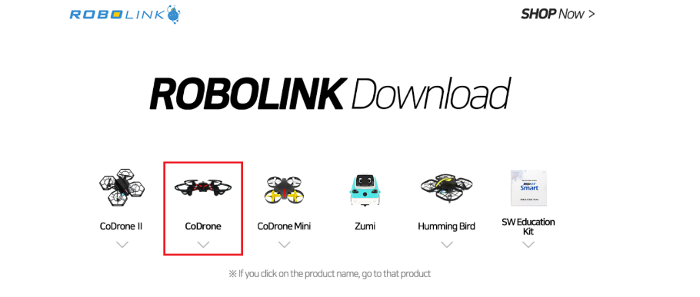
3. Click and download in the red box. Choose if you have Windows or MacOS.
   1. 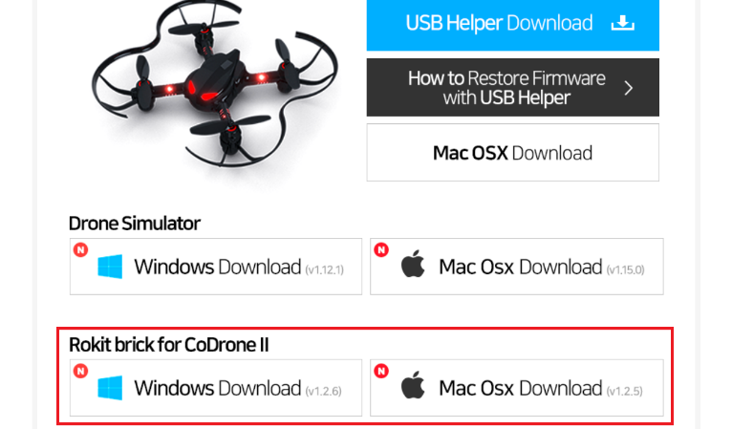
4. Save the zip file in you desired area. I suggest saving it in a new folder and place it somewhere you will remember.
   1. 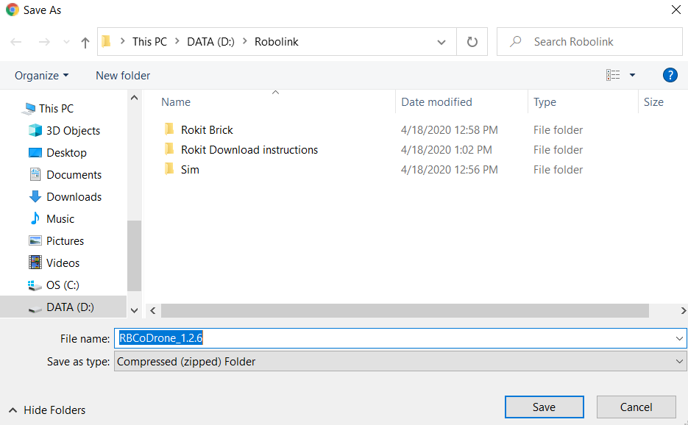
5. The download can take 13+ minutes depending your Wi-Fi speed.
   1. 
6. Once you finished downloading. Right click on the RBCoDrone_1.2.6 zip file and extract the file.
   1. 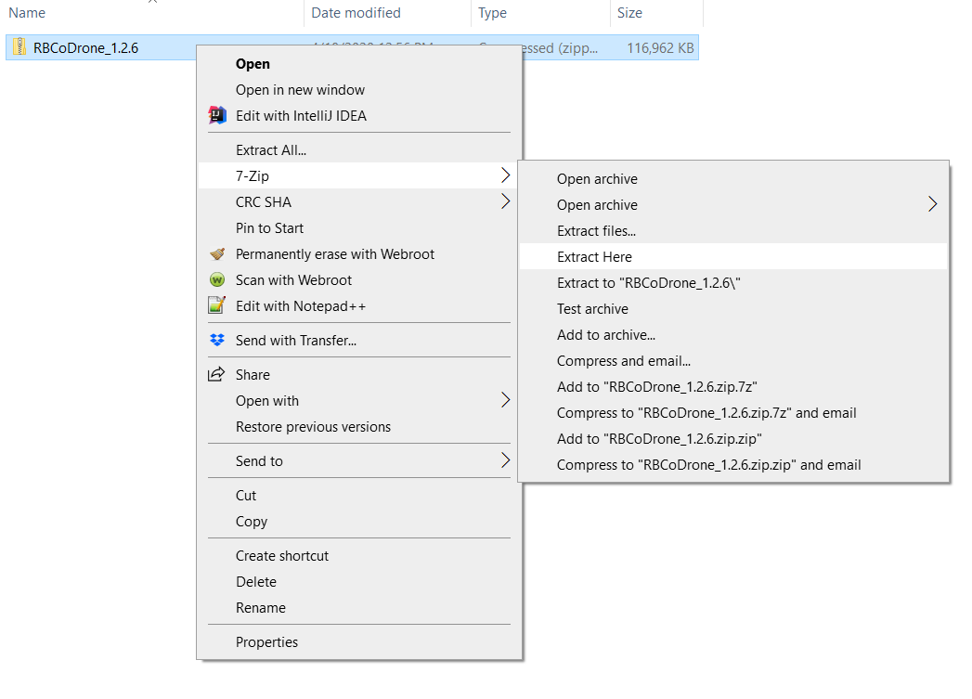
7. Once extracted open RBCodrone_126 Folder.
   1. 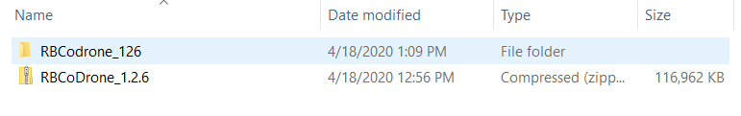
8. Click and open RBCodrone application.
   1. 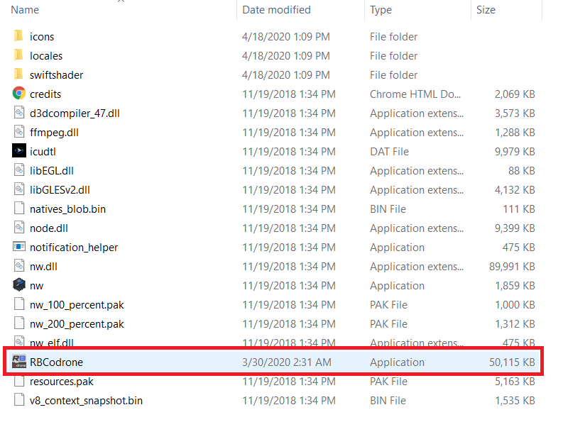
9. Codrone should the first in the picture and click on select.
   1. 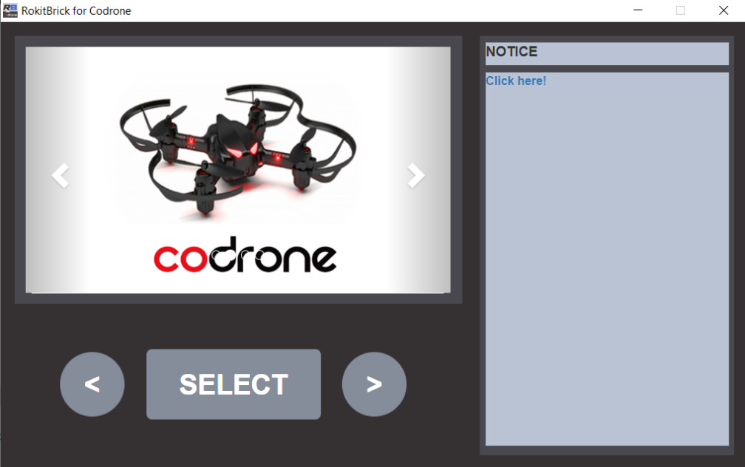
10. Once selected the window should be like this.
    1. 